Teacher Notes for “How Whales Evolved – Evidence and Scientific Arguments”

Students begin by comparing the characteristics of whales, mammals and fish to decide whether whales should be classified as mammals or fish. To support their conclusion, students make a scientific argument (claim, evidence, reasoning). Students learn about the evolution of whales and other cetaceans by analyzing evidence from comparative anatomy, embryology, fossils, and DNA and proteins. Finally, students make a scientific argument for the claim that whales and other cetaceans evolved from land mammals.

Learning Goals
In accord with the Next Generation Science Standards (NGSS):
- This activity helps students to prepare for Performance Expectation, HS-LS4-1. “Communicate scientific information that common ancestry and biological evolution are supported by multiple lines of empirical evidence.”
- This activity helps students to understand the Disciplinary Core Idea, LS 4.A: Evidence of Common Ancestry and Diversity. “Genetic information provides evidence of evolution. DNA sequences vary among species, but there are many overlaps; in fact, the ongoing branching that produces multiple lines of descent can be inferred by comparing the DNA sequences of different organisms. Such information is also derivable from the similarities and differences in amino acid sequence and from anatomical and embryological evidence.”
- Students engage in the Scientific Practices:
  - “Engaging in an Argument from Evidence. Construct… a written argument… based on data and evidence. Make and defend a claim based on evidence about the natural world…”
  - “Constructing Explanations. Apply scientific ideas, principles and/or evidence to provide an explanation of phenomena and solve design problems…”
- This activity helps students understand the Crosscutting Concept, “Scale, Proportion and Quantity. Some systems [phenomena] can only be studied indirectly as they are too small, too large, too fast, or too slow to observe directly.”
- This activity helps students understand the Nature of Science, including:
  - “Scientific argumentation is a mode of logical discourse used to clarify the strength of relationships between ideas and evidence.”
  - “Scientific investigations use a variety of methods, tools, and techniques to revise and produce new knowledge.”
  - “A scientific theory [e.g., the theory of evolution] is a substantiated explanation of some aspect of the natural world, based on a body of facts that have been repeatedly confirmed through observation and experiment, and the science community validates each theory before it is accepted.”

Instructional Suggestions and Biology Background
To maximize student participation and learning, I suggest that you have your students work individually or in pairs to complete each group of related questions and then have a class discussion after each group of questions. In each discussion, you can probe student thinking and help them develop a sound understanding of the concepts and information covered before moving on to the next group of related questions.

If your students are learning online, I recommend that they use the Google Doc version of the Student Handout available at https://serendipstudio.org/exchange/bioactivities/whale evolution. To answer question 9, students can either print the relevant page, draw on it and send pictures to you, or they will need to know how to modify a drawing online. To answer online, they can double-click on the relevant drawing in the Google Doc to open a drawing window. Then, they can use the editing tools to answer the question. You may want to revise the GoogleDoc or Word document to prepare a version of the Student Handout that will be more suitable for your students; if you do this, please check the format by viewing the PDF.

A key is available upon request to Ingrid Waldron (iwaldron@upenn.edu). The following paragraphs provide additional instructional suggestions and background information – some for inclusion in your class discussions and some to provide you with relevant background that may be useful for your understanding and/or for responding to student questions.

Are whales mammals or fish?
To stimulate student interest, you may want to show them:
- Our Planet – Humpback Whales (a 4 minute video; https://www.youtube.com/watch?v=glxULceEEjA) or
- Gray Whale Migration (a 2-minute video; https://oceantoday.noaa.gov/graywhalemigration/).

Students begin by comparing the characteristics of whales with the characteristics of mammals vs. fish. Similarities in the overall appearance of whales and fish will be revisited on page 4 of the Student Handout when we discuss analogous vs. homologous structures (see page 8 of these Teacher Notes).

If your students are not familiar with the differences between mammalian lungs and fish gills, you may want to use the two figures below to explain the differences. The narrow tubes leading to the lungs reduce water loss and prevent the moist surface of the alveoli from drying out. Since air is much lighter than water and air has a higher concentration of oxygen, mammals can use the relatively inefficient method of pumping air in and out of the lungs. In contrast, fish pump water in one direction across their gills (see second figure below). In fish gills, the efficiency of gas exchange is increased by the countercurrent mechanism shown.
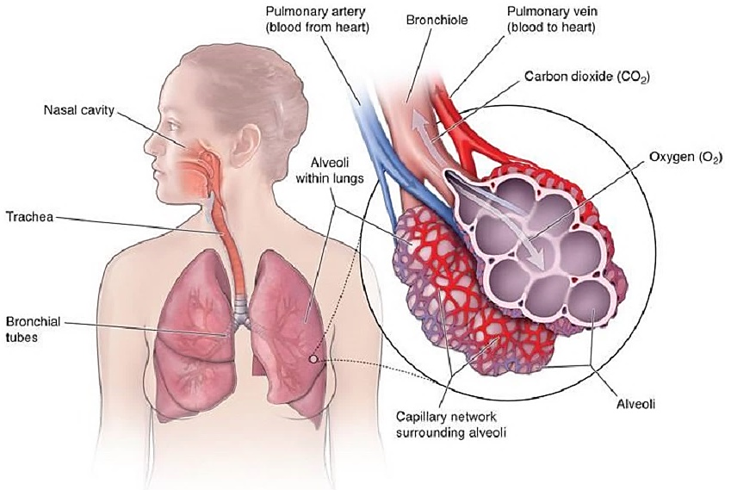
O₂

(https://www.templehealth.org/sites/default/files/inline-images/alveoli_small_0.jpg)

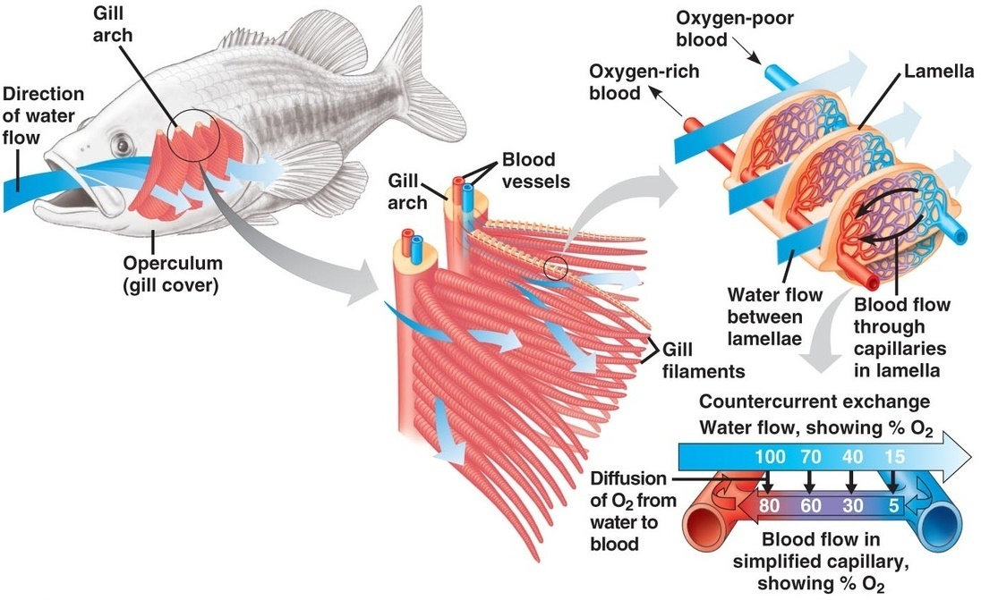
(https://www.iitbmonash.org/wp-content/uploads/2016/11/iitbm-story88-1.jpg)

The table on page 1 of the Student Handout describes mammals as warm-blooded; this means that they are:
- endotherms (Their metabolism generates most of their heat internally.)
- homeotherms (They regulate their body temperatures, typically at relatively high body temperatures.)
Fish are described as cold-blooded; this means that they are:
- exotherms (They gain most of their heat from external sources; however, some fish use countercurrent exchange of heat to keep their swimming muscles warmer than the environment.)
- poikilotherms (They generally have limited capacity to regulate their body temperature, although terrestrial poikilotherms can thermoregulate to some extent by behavioral adjustments, such as moving into or out of the sun.)
(https://www.khanacademy.org/science/ap-biology/ecology-ap/energy-flow-through-ecosystems/a/endotherms-ectotherms)

If your students are already familiar with why and how to make a scientific argument, you may want to skip the recommended 7-minute video, “The Trouble with Cognitive Bias” (https://learn.genetics.utah.edu/content/evolution/bias). To supplement this video, you will probably want to introduce additional concepts about common cognitive biases from https://www.verywellmind.com/cognitive-biases-distort-thinking-2794763. If this is your students’ first introduction to scientific arguments, you may want to supplement the video by showing your students the contrast between a well-constructed scientific argument vs. a poor scientific argument, together with criteria for evaluating scientific arguments (https://teach.genetics.utah.edu/content/evolution/biochemistry/pdfs/Evaluating-arguments_insulin-example.pdf).

The Evolution of Whales
Cetaceans include whales, dolphins and porpoises. Cetaceans are fully aquatic. They should be distinguished from:
- pinnipeds, which include sea lions, fur seals, and the walrus; pinnipeds are semiaquatic (since they mate and give birth on land);
- sirenians, which include dugongs and manatees; sirenians are fully aquatic.

The living cetaceans can be divided into two major groups:
- the Odontocetes, which include whales, dolphins and porpoises that have teeth and use echolocation for hunting;
- the Mysticetes, the baleen whales which open their mouths to take in water and then push water out through their baleen, which filters out small crustaceans (e.g. krill) and small fish (see figures below).

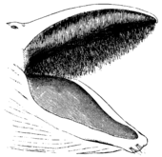  baleen  (https://en.wikipedia.org/wiki/Baleen) | 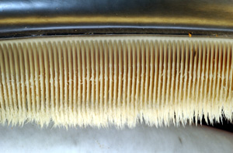

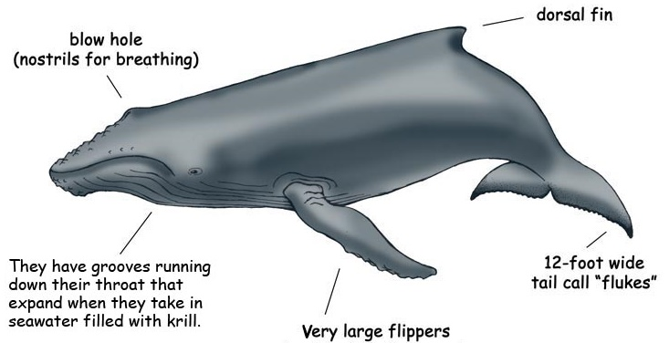
(External appearance of humpback whale, a baleen whale; https://www.exploringnature.org/graphics/mammals/whale_humpback_diagram.jpg)

For more information about the biology of cetaceans, see:
- “Cetacea” (https://animaldiversity.org/accounts/Cetacea/).
- Whale Anatomy (a 3-minute video; https://oceantoday.noaa.gov/whaleanatomy/) and Whales 101 (a 3-minute video; https://oceantoday.noaa.gov/whales101/welcome.html)
- Killer Whale Anatomy (a 3.5-minute video; https://oceantoday.noaa.gov/killerwhaleanatomy/) and Killer Whales 101 (a 3.5-minute video; https://oceantoday.noaa.gov/killerwhales101/welcome.html)
- Whale Song (a three-minute video; https://www.youtube.com/watch?v=WabT1L-nN-E)

The recommended 10-minute video, “What Is the Evidence for Evolution?” (https://www.youtube.com/watch?v=lIEoO5KdPvg), provides a good summary of four types of evidence for cetacean evolution from land mammals to a fully aquatic existence. Near the end of the video, the narrator says, “Humans share a fairly recent ancestor with chimpanzees.” You may want to emphasize that chimpanzees are not the evolutionary ancestors of humans (see figure below).
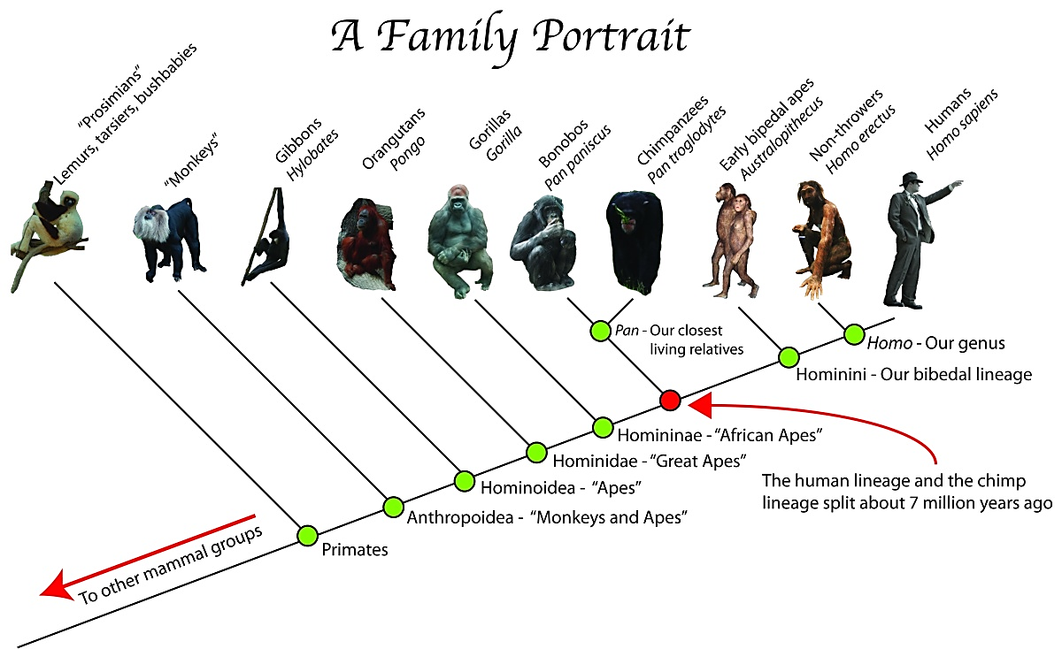
(https://culturalandscape.files.wordpress.com/2011/01/ape-family-tree-a-family-portrait-pasttime-org-episode-5-throwing-in-human-evolution.jpg?w=1200)

The comparative anatomy evidence in the recommended video is similar to the evidence presented on page 1 of the Student Handout.

Molecular evidence includes both the nucleotide sequence in DNA and the amino acid sequence in proteins. These are closely related because the sequence of nucleotides in a gene in the DNA specifies the sequence of amino acids in a protein. Organisms that share a more recent evolutionary ancestor have a more similar sequence of nucleotides in their DNA since there has been less evolutionary time for mutations to accumulate. Substantial molecular evidence supports the conclusion that cetaceans belong in the same order with Artiodactyla (even-toed hoofed land mammals) (https://www.sciencedirect.com/science/article/pii/S1055790318302720).

Question 8 provides the opportunity to discuss how scientists use estimated number of mutations in a gene to infer which organisms share more recent evolutionary ancestors. The molecular evidence indicates that the closest living relatives of cetaceans are the hippopotamus species.

Genes direct the embryological development of anatomical characteristics. Scientists have begun to link some of the differences in DNA and proteins to differences in the macroscopic anatomy of cetaceans, compared to land mammals. As would be expected, the molecular evidence generally supports evolutionary relationships that have been based on comparative anatomy, embryology, and fossils. However, because the molecular evidence is more detailed, it can clarify evolutionary relationships. On the other hand, fossils can be dated, so the fossil evidence indicates the timing of the various modifications during cetacean evolution. Thus, the different types of evidence complement each other.

The fossil evidence reviewed in the recommended video and on page 3 of the Student Handout shows a variety of fossil cetaceans with intermediate characteristics that are increasingly adapted to an aquatic lifestyle. The video uses color differences to distinguish between fossil bones that have been discovered, bones that have been inferred, and inferred body shapes. The figure below provides additional information about some of the fossils.
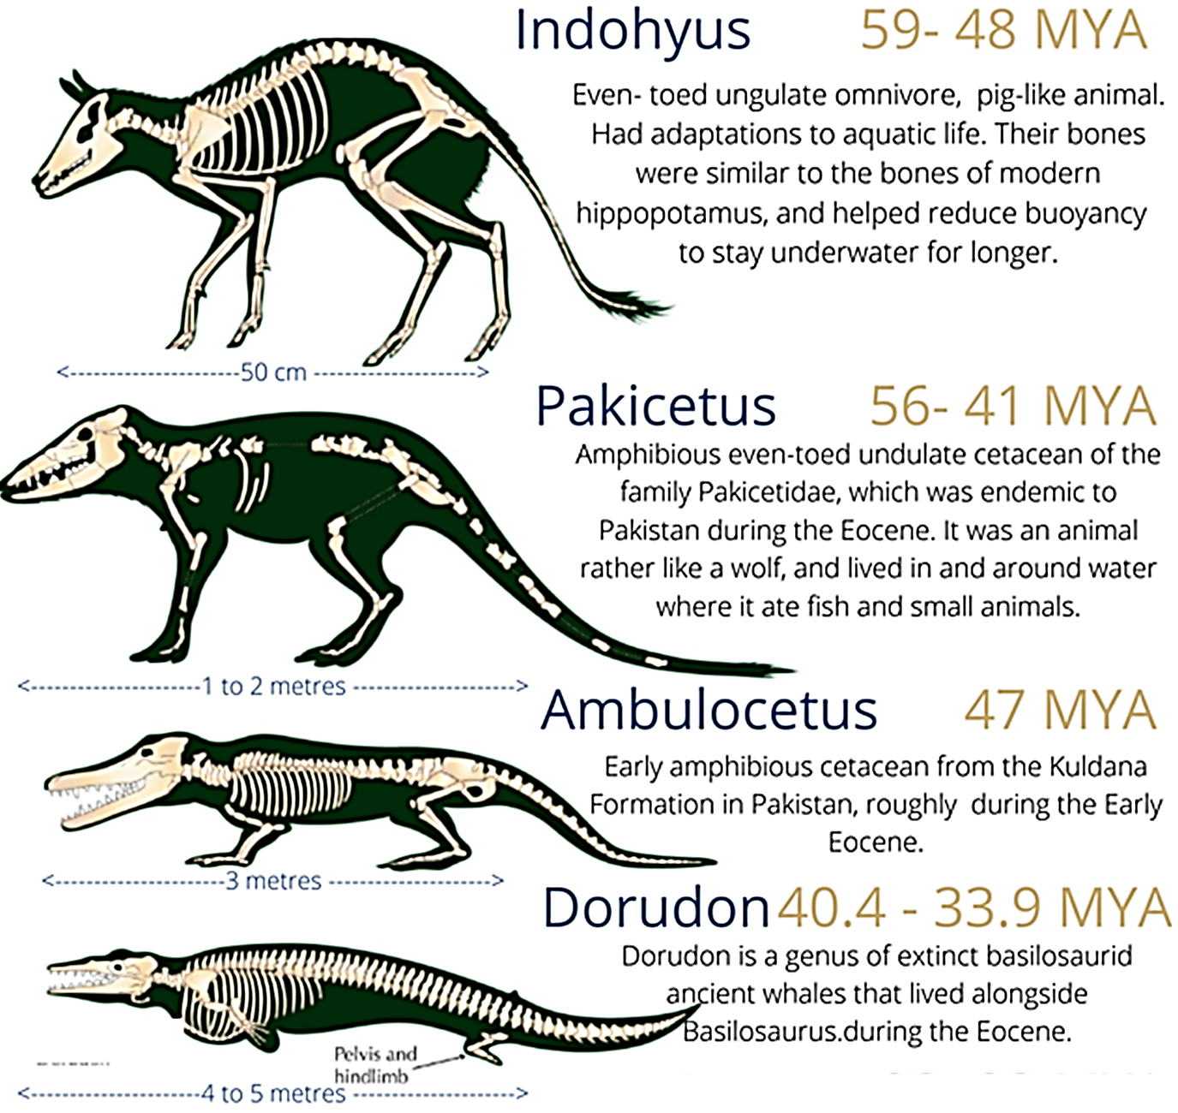
(https://lirp.cdn-website.com/8c8ca5ab/dms3rep/multi/opt/Whale+Evolution+%282%29-640w.png)

The figure on page 3 of the Student Handout clarifies that the extinct cetacean species preserved in fossils are not assumed to be the direct ancestors of modern cetaceans. Rather, the fossil species indicate the variety of adaptations that evolved in extinct cetaceans. For example, in Maiacetus (in the video) and in Rodhocetus (in the Student Handout), the well-developed hindlegs appear to have been used as paddles for swimming; this contrasts with the absence of hindlegs in modern cetaceans and the tail flukes which modern whales use to propel themselves through the water. Notice that evolution is not a story of steady “progress”. Instead, evolution often produces a diversity of species, many of which become extinct.

Answering question 9 will reinforce student understanding that whale evolution involved both new anatomical features (the tail flukes) and loss of anatomical features (the hind legs). Taking a longer view, legs evolved when vertebrates first moved on land (see figure below). Then, much later, during cetacean evolution, evolution of the front legs produced flippers (used for steering) and evolution of the back legs resulted in their reduction to tiny internal structures. The contrast between the earlier tetraprod evolution of legs vs. the later cetacean evolution of no external hindlegs should reinforce student understanding that evolution is not a story of “progress”, but rather a story of changes in the characteristics of populations of organisms as the organisms exploit new ecological niches and become more well-adapted to their environment and way of life.
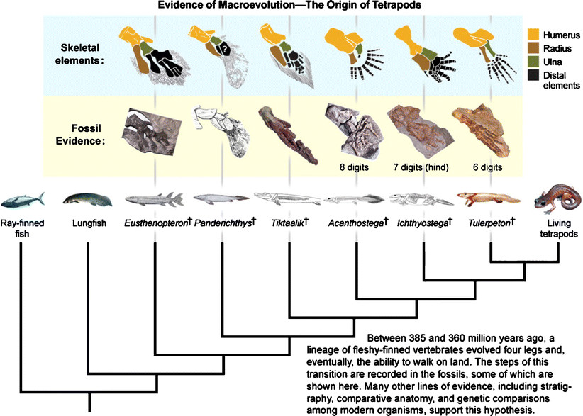
(https://www.researchgate.net/publication/225497328_Transforming_Our_Thinking_about_Transitional_Forms)

The embryological evidence in the video and on page 4 of the Student Handout shows:
- the early development of hindlimb buds, which stop growing during later embryological development and do not develop into legs;
- the movement of the nostrils from the position above the mouth in early embryos to the blowhole position near the top of the head in later embryos. (The blowhole position allows cetaceans to breathe air with minimal surfacing).
These observations illustrate the generalizations that:
- Embryos often have some characteristics of evolutionary ancestors that are absent in the adults.
- Often, later stages of embryological development are modified to produce characteristics that evolved more recently.
To understand why, consider that mutations that occur early in an embryo’s development are more likely to be “lethal, because of the fundamental changes that they will involve. That is why we tend to see more mutations in the later stages of development, and why various species show similarities in their early embryonic stages.” (https://thebrain.mcgill.ca/flash/capsules/outil_bleu12.html)

Biologists use several types of evidence to determine whether similar structures in different species are homologous or analogous. For example, the fossil evidence shown on page 7 of these Teacher Notes supports the interpretation that the detailed similarities of the bones in the forelimbs of mammals are due to shared evolutionary ancestors, so they are homologous structures.  Two observations support the conclusion that these mammalian bones are analogous (not homologous) to the fin rays in fish fins. The fin rays are made of a different type of bone (dermal bones in fish fins vs. endochondral bone for all mammalian bone). Also, the fin rays lack the joints seen in the digits of most types of mammals (http://thatslifesci.com/2017-05-25-Fins-Limbs-Rays-Digits-Navon/).  The tail fin of fish and the tail flukes of whales evolved independently, so they are also analogous structures. An additional clue that these structures evolved independently is that the tail fin of fish is vertical, whereas the | 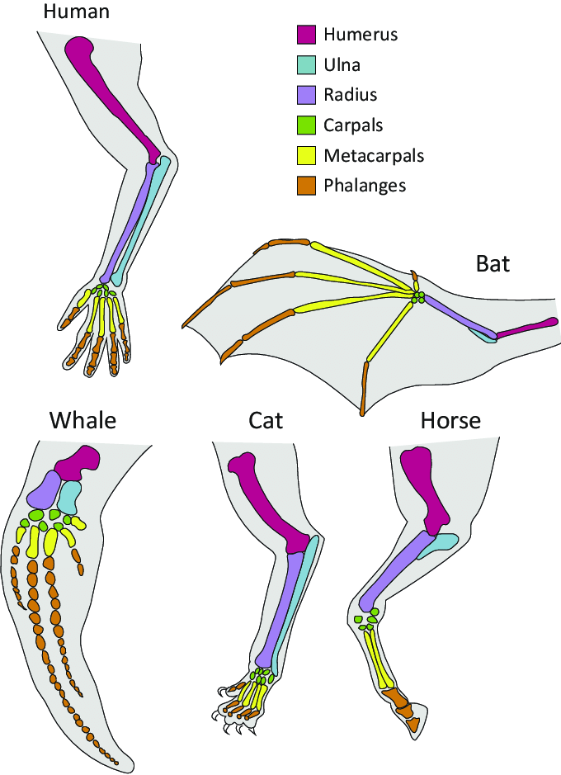  (https://www.researchgate.net/profile/Tony-Prescott/publication/328049189/figure/fig6/AS:678150803570689@1538695159274/Examples-of-Forelimb-Diversity-in-Mammals-These-drawing-indicate-similar-bones-of-the.png)
tail flukes of whales are horizontal (see pictures on page 1 of the Student Handout). Correspondingly, fish are propelled by side-to-side tail movements, whereas whales are propelled by up-and-down tail movements. (You can see this contrast by comparing the videos of cetaceans and fish swimming at https://www.youngoceanexplorers.com/yoe/video/235268530371#cplayer and https://bikehike.org/are-there-any-fish-with-horizontal-tail-fins/.)

The figure below shows that convergent evolution produced the streamlined shape of fish and cetaceans. Thus, streamlined shape is an analogous characteristic that minimizes drag as the animals move through water.
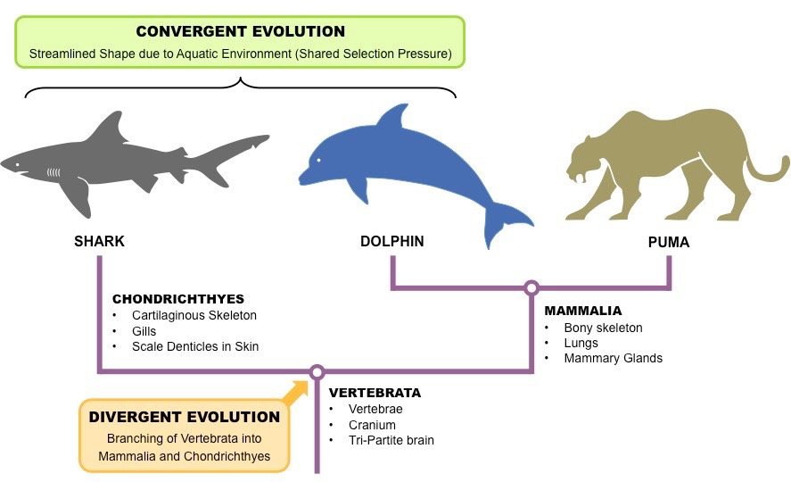
(https://ib.bioninja.com.au/standard-level/topic-5-evolution-and-biodi/54-cladistics/structural-evidence.html)

After your students have answered question 11, you may want to return to page 1 of the Student Handout and ask your students which similarities are homologies and which are analogies.

As students answer question 12, they will revisit the multiple lines of evidence for the evolution of cetaceans and, at the same time, develop their ability to make a scientific argument. You may want to suggest that students review the evolution video and pages 2-4 of the Student Handout as they answer question 12.

I suggest a concluding discussion of the following points:
- “Some systems [phenomena] can only be studied indirectly as they are… too slow to observe directly.” (Crosscutting Concept)
- “Scientific investigations use a variety of methods, tools, and techniques to revise and produce new knowledge.” (Nature of Science)
- “A scientific theory [e.g. the theory of evolution] is a substantiated explanation of some aspect of the natural world, based on a body of facts that have been repeatedly confirmed through observation and experiment, and the science community validates each theory before it is accepted.” (Nature of Science) This contrasts with a common usage of the word “theory” to describe a speculation. Your students may find it helpful to distinguish big T scientific THEORY and little t common usage theory.

Recommended sources of additional information include:
- “The time when whales walked – evolution of whales” (a 5-minute video that focuses on the fossil evidence and the environmental conditions when these extinct species arose; https://www.youtube.com/watch?v=btXMKN-SI48)
- “The Tale of the Whale: An Ideal Case Study for Introducing the Evidence for Evolution” (a 23-minute video that provides more information about the whole range of evidence; https://biologos.org/resources/the-tale-of-a-whale-an-ideal-case-study-for-introducing-the-evidence-for-evolution)
- Fish or Mammals? (https://teach.genetics.utah.edu/content/evolution/ancestry/pdfs/cetaceans_case-study.pdf) (This is the source of the information in the tables on pages 1-2 of the Student Handout.)
- A Whale of a Tale? – The Evidence for the Evolution of Whales (https://www.nsta.org/ncss-case-study/whale-tale)

Sources for Figures in Student Handout
- Hippopotamus with baby – https://qph.fs.quoracdn.net/main-qimg-f5e109122904f30b6fd86bce07f7616e
- Fish – https://i.pinimg.com/originals/72/c3/ae/72c3aedc17e84385db91514060287fed.jpg
- Whale with baby – https://images.fineartamerica.com/images-medium-large-5/a-humpback-whale-calf-hides-corey-ford.jpg
- Fossil evidence for cetacean evolution – adapted from https://www.drneurosaurus.com/2016/04/
- Humpback whale with tail flukes – https://encrypted-tbn0.gstatic.com/images?q=tbn:ANd9GcTFpz_wxmoajMUR9vC43I585dF6cDwrITQAi25AMapoBa1s8geQwbVIRCRcc_qgwkQggKw&usqp=CAU
- Embryology of cetaceans – https://teach.genetics.utah.edu/content/evolution/ancestry/pdfs/cetaceans_case-study.pdf
- Homologous and analogous structures – adapted from https://www.researchgate.net/profile/Tony-Prescott/publication/328049189/figure/fig6/AS:678150803570689@1538695159274/Examples-of-Forelimb-Diversity-in-Mammals-These-drawing-indicate-similar-bones-of-the.png and https://media.springernature.com/full/springer-static/image/art%3A10.1038%2Fnature19425/MediaObjects/41586_2016_Article_BFnature19425_Fig1_HTML.jpg

By Dr. Ingrid Waldron, Dept Biology, University of Pennsylvania. © 2022. The Student Handout and these Teacher Notes are available at https://serendipstudio.org/exchange/bioactivities/whale evolution.
Quotations are from http://www.nextgenscience.org/sites/default/files/HS%20LS%20topics%20combined%206.13.13.pdf
To draw a shape, at the top of the page, find and click Shape, choose the shape you want to use, and click and drag on the canvas to draw your shape. When you are done, click Save and Close.
Pinnipeds evolved from land carnivores and sirenians are related to elephants. The similar overall body forms of cetaceans, pinnipeds and sirenians illustrate convergent evolution.
Casein is a major protein in mammalian milk. Casein helps to solubilize calcium phosphate, thus allowing milk to have a high concentration of calcium phosphate which is needed for bones and teeth. Molecular evidence suggests that the genes for caseins were derived from genes for proteins that were involved in depositing calcium phosphate in teeth in the evolutionary ancestors of mammals (https://academic.oup.com/mbe/article/28/7/2053/1047188).
The video points out that whales have multi-chambered stomachs, similar to a hippopotamus stomach. Hippopotamuses eat mainly grasses, which are harder to digest than food derived from animals; the extra chambers in a hippopotamus stomach house bacteria that digest the cellulose in plant cell walls.
For example, to investigate cetacean evolution, scientists have evaluated more than 10,000 protein-coding DNA sequences.
In the Student Handout figure, "Complete loss of back legs" refers to the absence of external back legs; some very small internal hind leg bones are observed in some species of living cetaceans.
Cetaceans evolved during a time when the movement of continents changed ocean currents which increased upwellings and food availability in the oceans (https://www.youtube.com/watch?v=btXMKN-SI48).
The idea that "ontogeny recapitulates phylogeny" has been discredited because some of the early evidence for this generalization was not accurate, because there are many exceptions, and because development does not re-create the adult stages of evolutionary ancestors. However, solid evidence supports the conclusion that "species that share the same branch of the evolutionary tree clearly also go through the same early stages of individual development, though they diverge subsequently." (https://thebrain.mcgill.ca/flash/capsules/outil_bleu12.html; pages 443-461 in Principles of Development by Wolpert et al, 1998)
Quotations from https://www.nextgenscience.org/

